* Install Node.js
* Run Command Prompt
* Install Npm Modules

: npm install -g truffle

: npm install -g web3

* Create and Init Smart contracts Projects using truffle module

: mkdir HelloContracts

: cd HelloContracts

: npm init

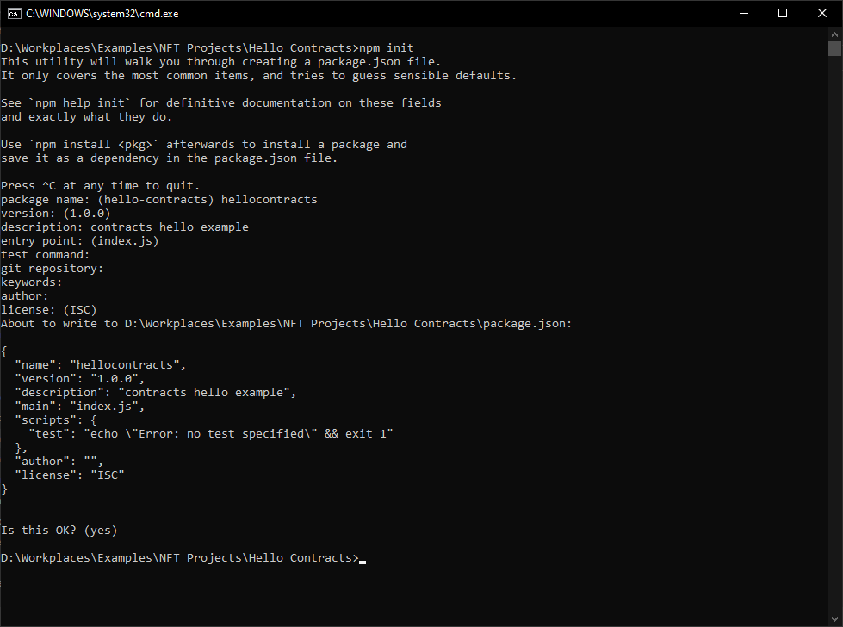

: truffle init

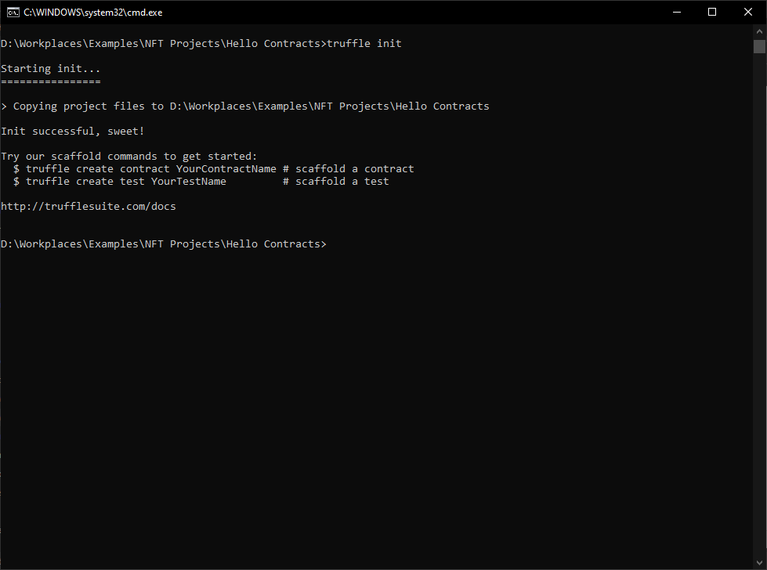

* Install node modules for building smart contracts

Open the Project folder with Visual Code.

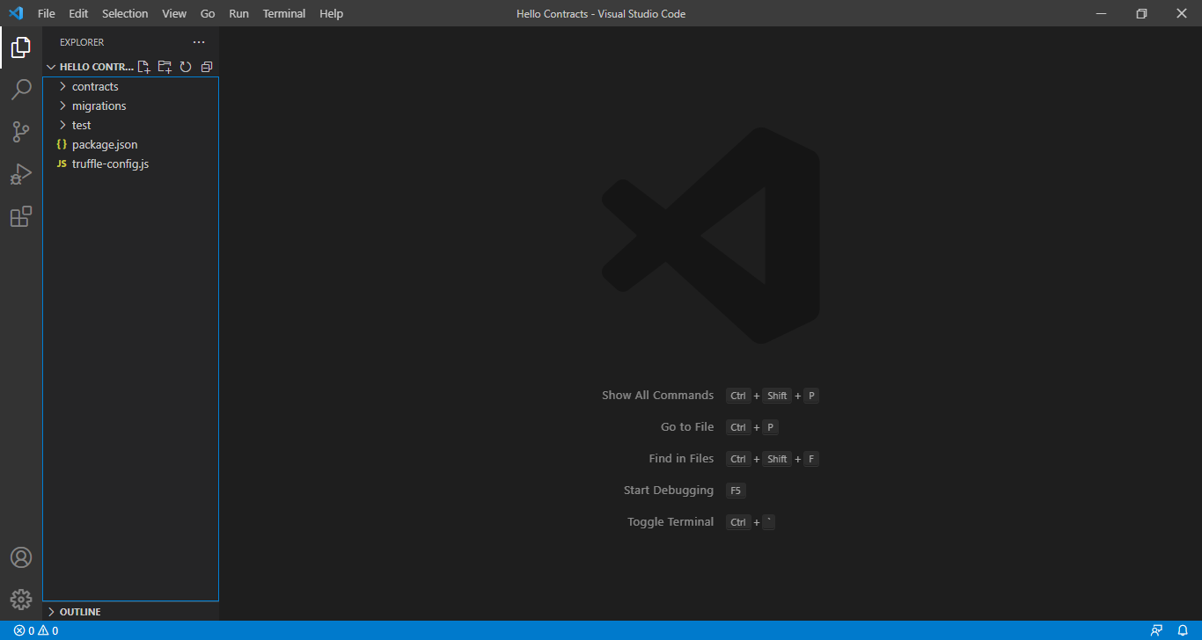

Install Npm modules

: npm install tslib dotenv

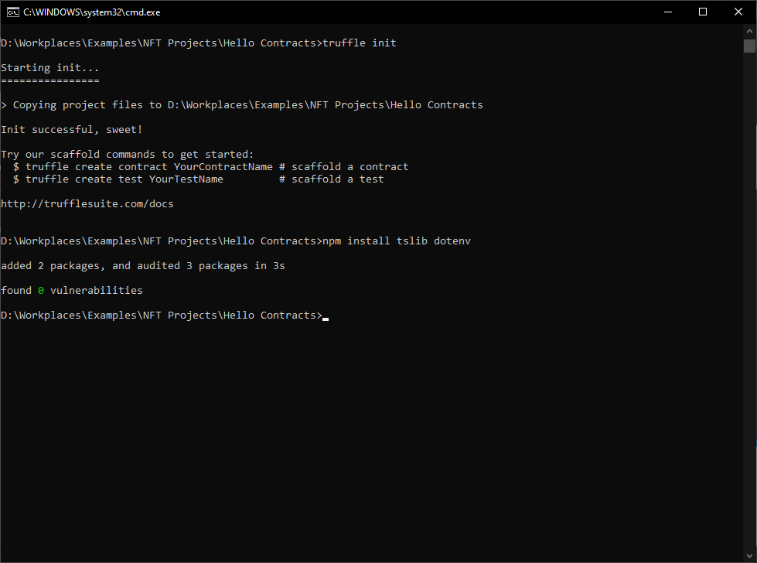

: npm install truffle

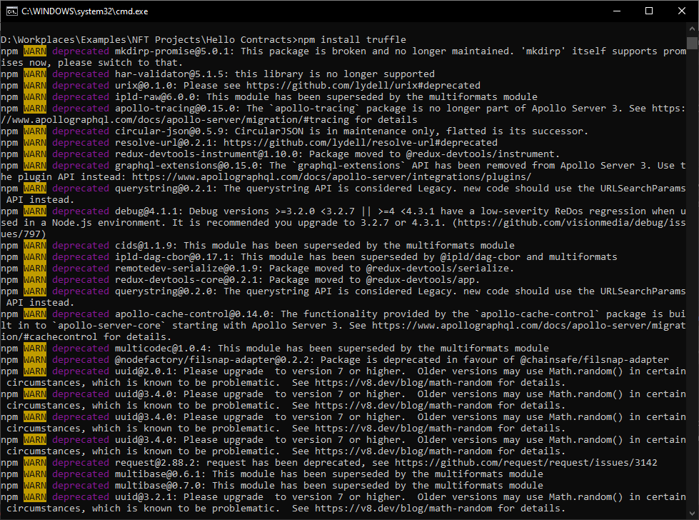

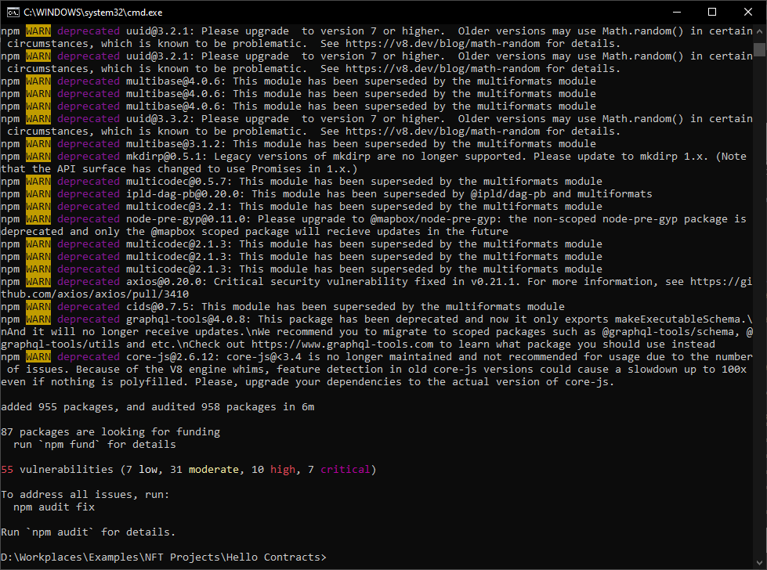

: npm install @truffle/hdwallet-provider

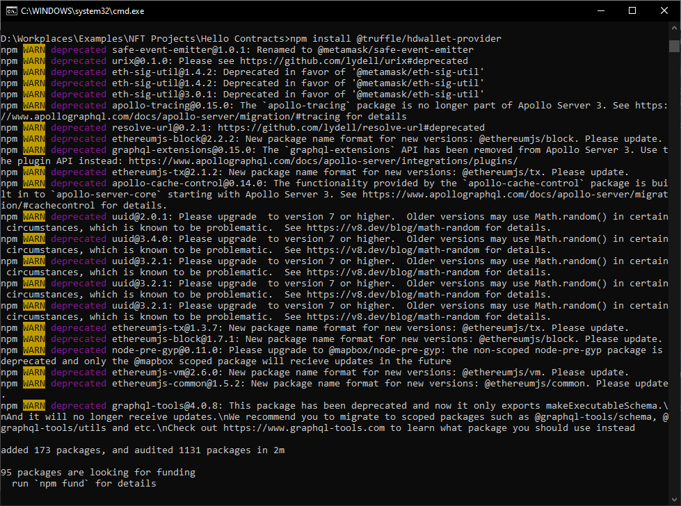

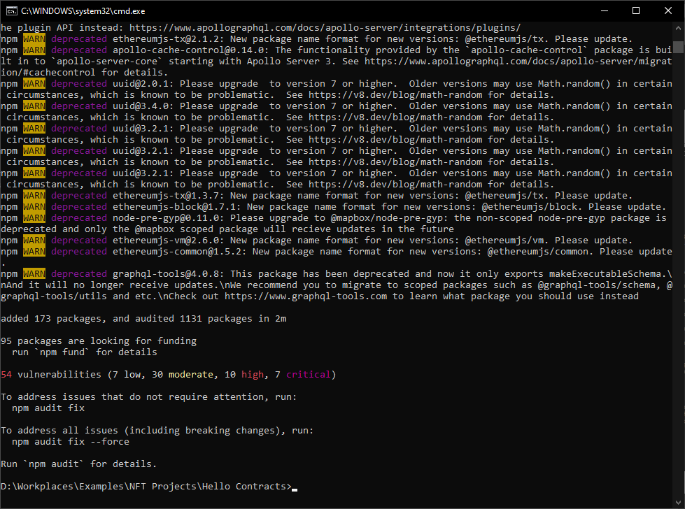

: npm install @openzeppelin/contracts

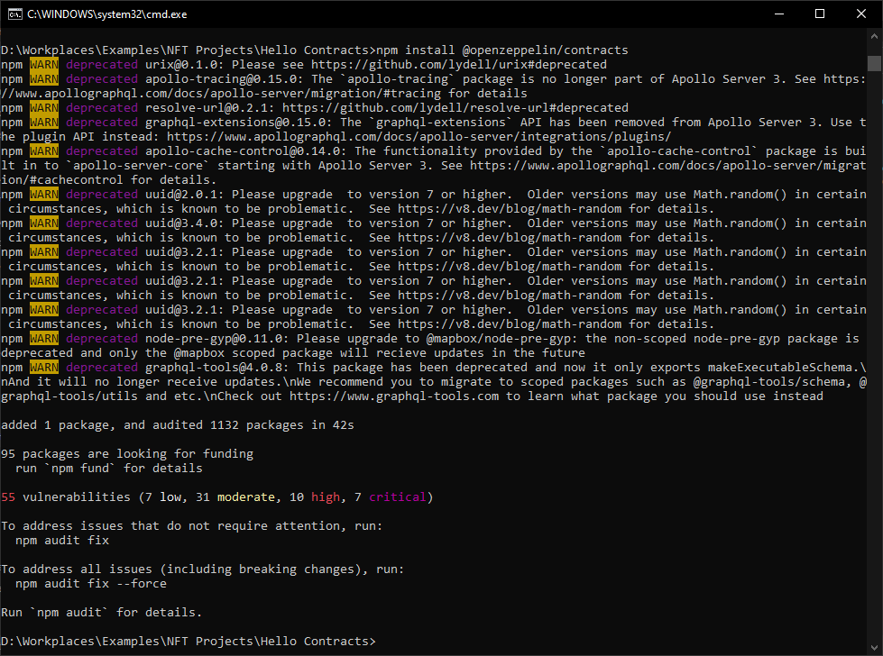

: npm install @harmony-js/core

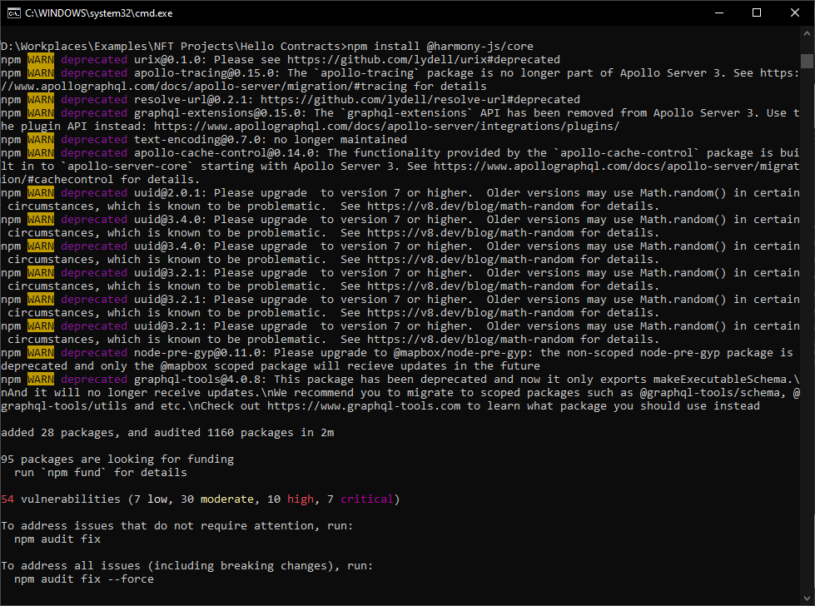

Open Visual Code And check project

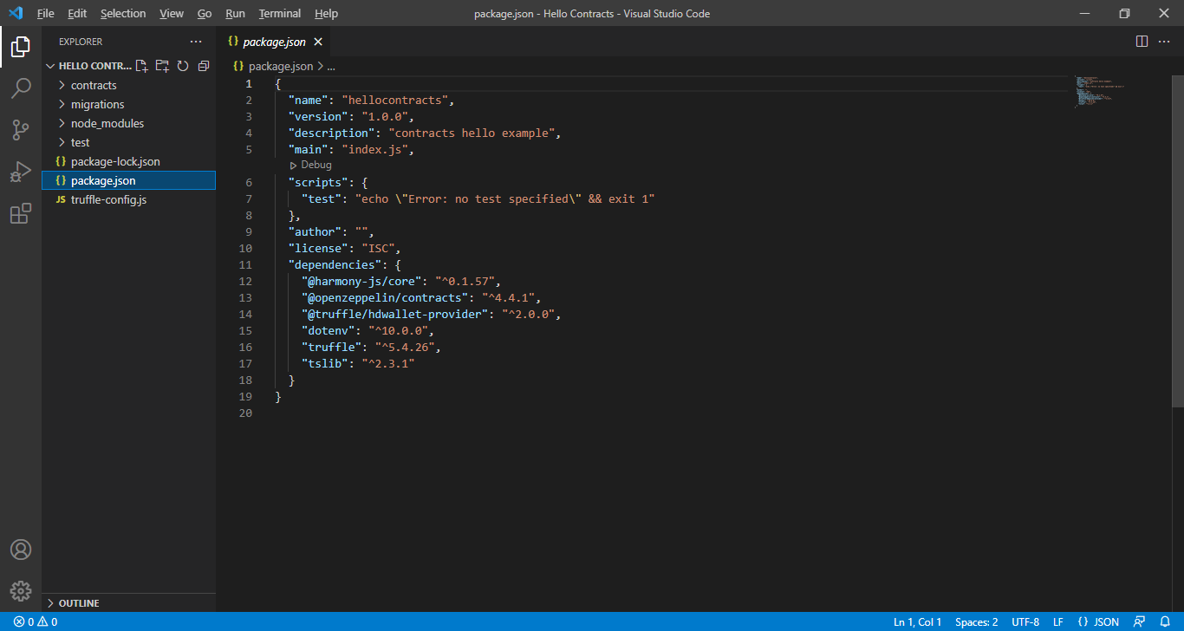

* Create a new file in the contracts/ folder called HelloWorld.sol.

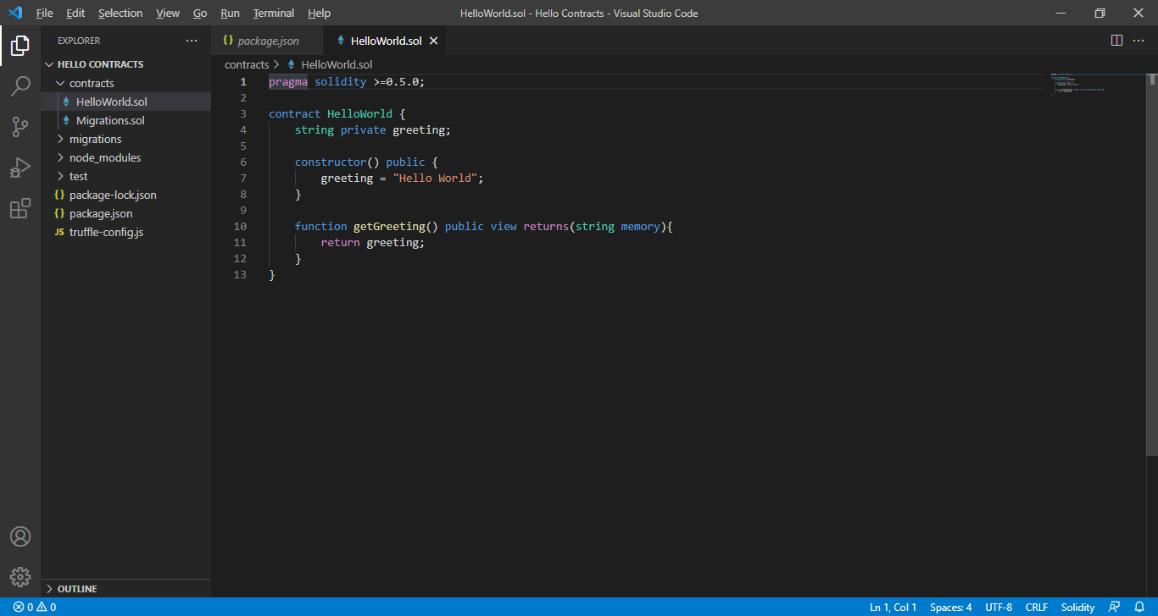

And remove “public” ( using old version) and Add “// SPDX-License-Identifier: MIT”

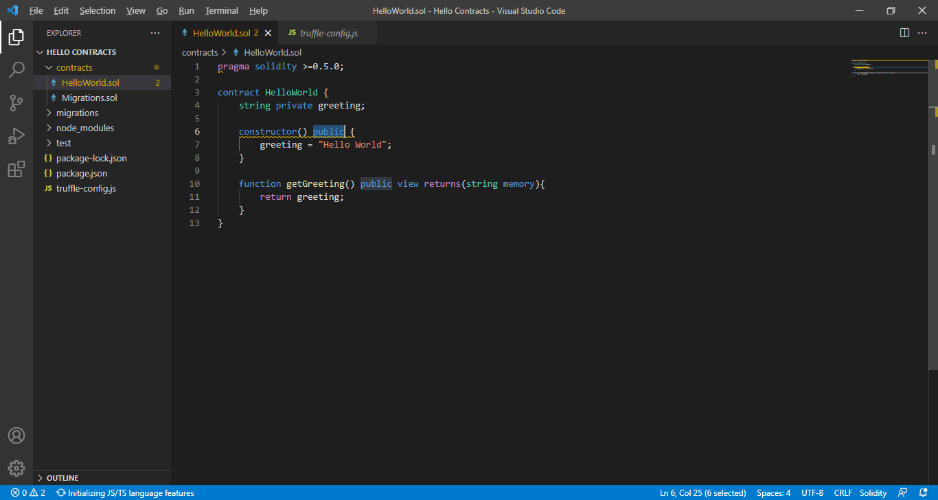

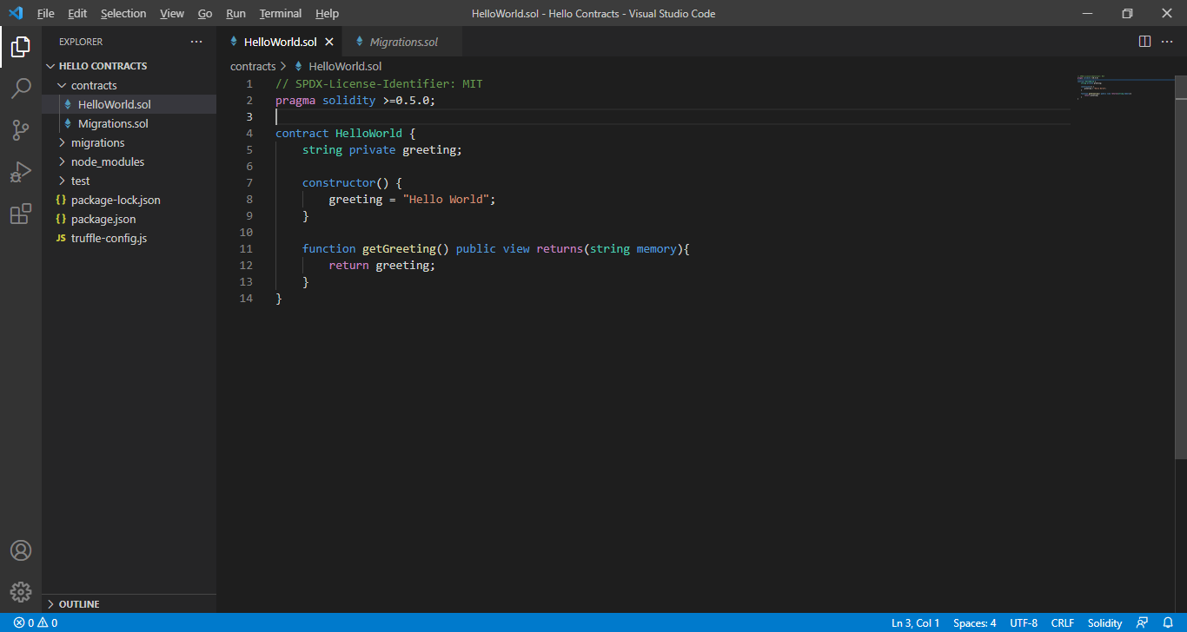

* Version check

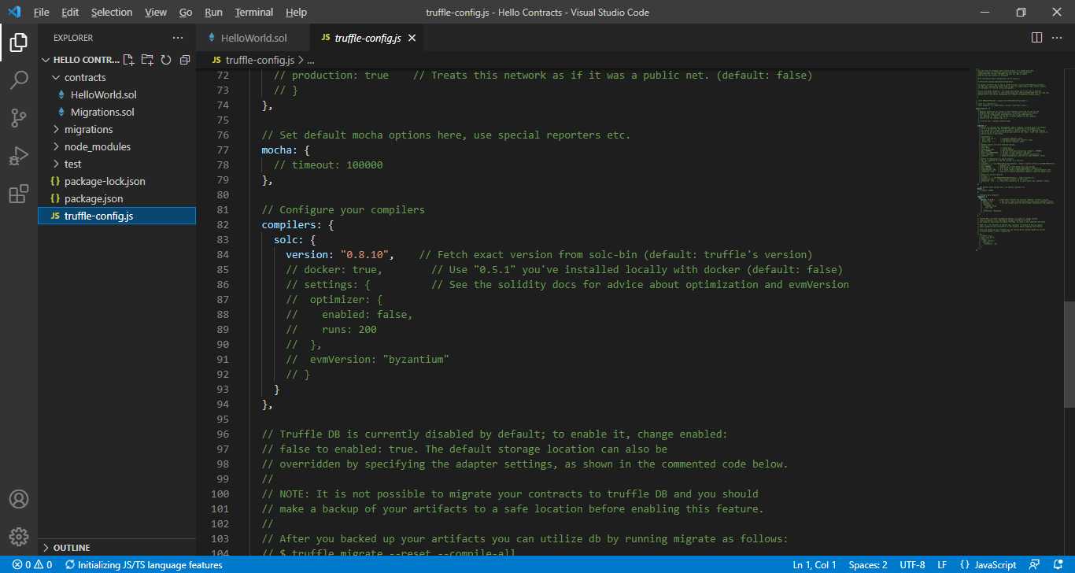

* Create a new file in the migrations/ folder called 2_deploy_contract.js.

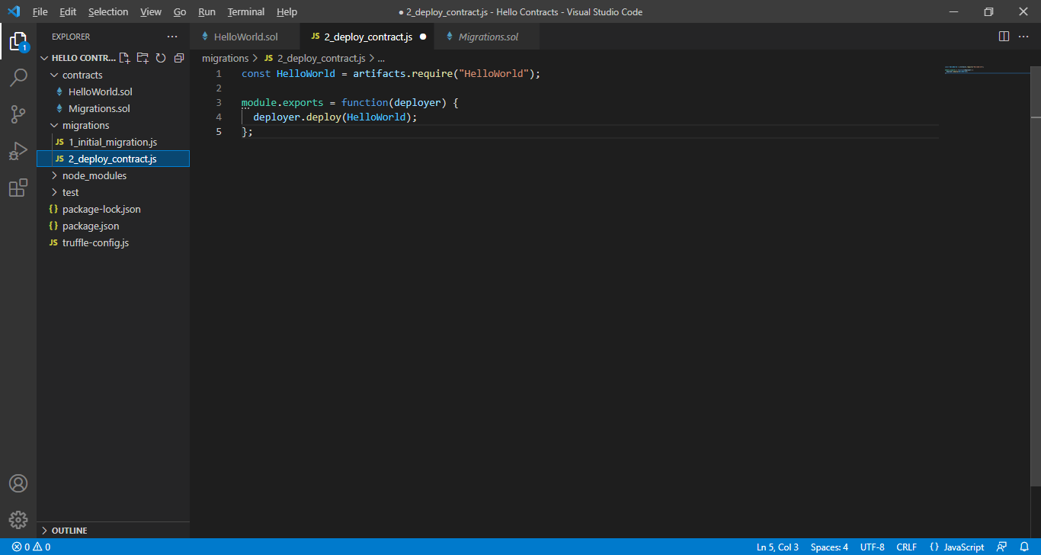

* Compile Projcet

: truffle compile

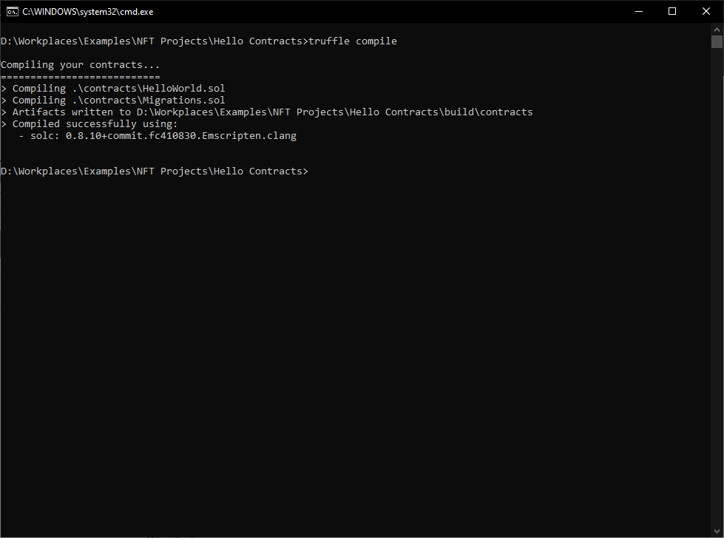

* Setting “truffle-config.js”

Get My Wallet’s Privatekey

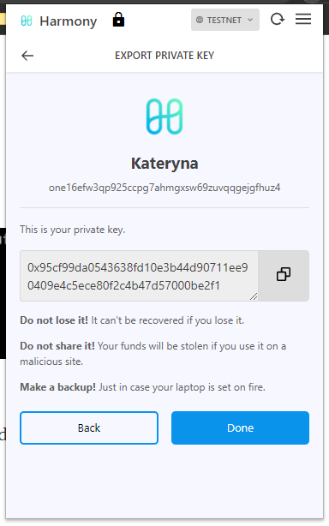

Write code “truffle-config.js”

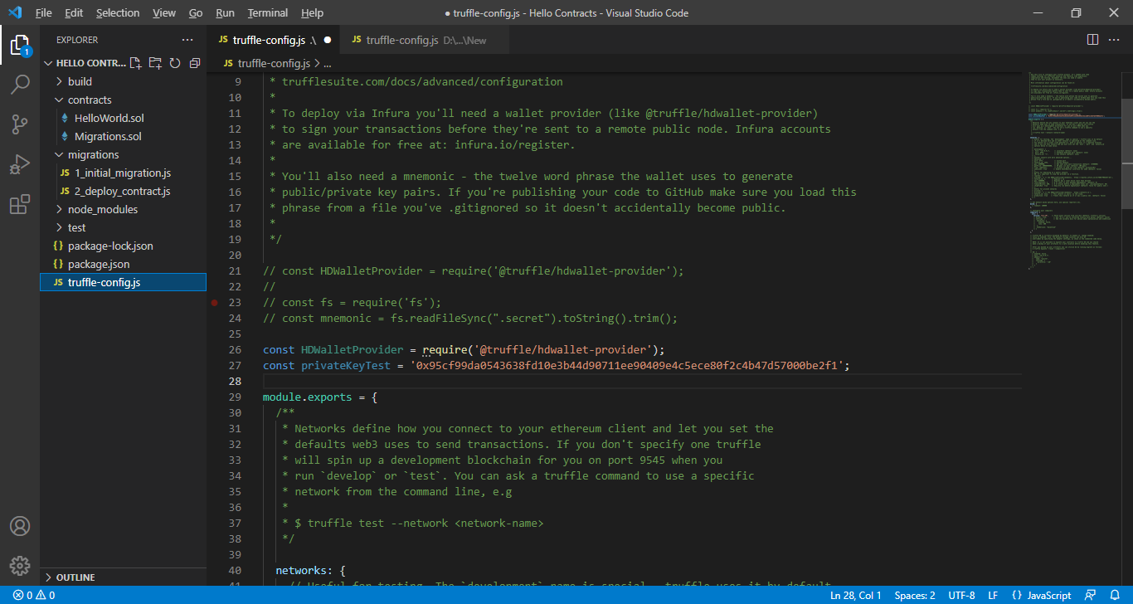

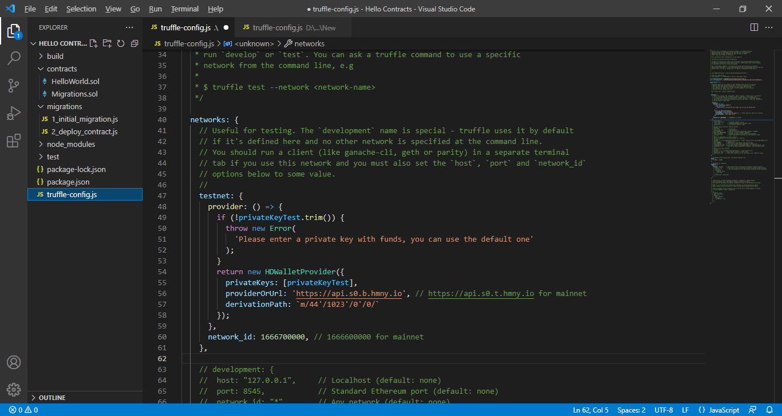

* Build Project

: truffle build

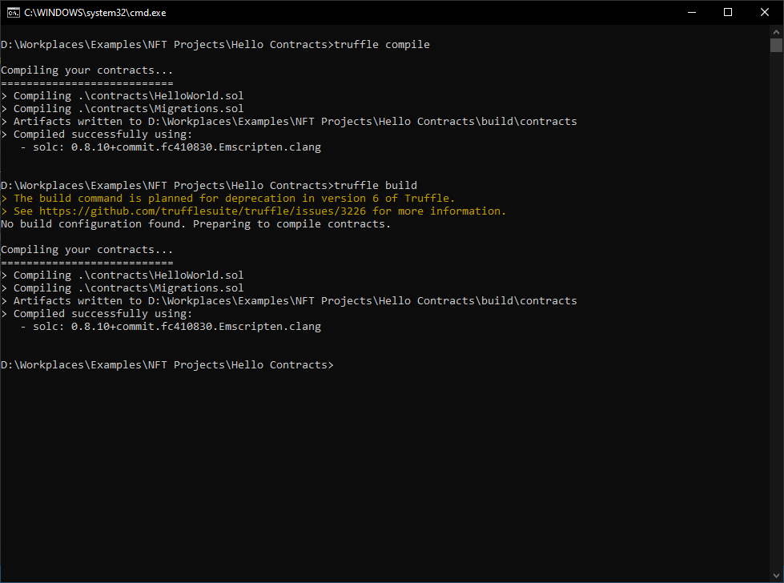

* Migration last

: truffle migrate --network testnet

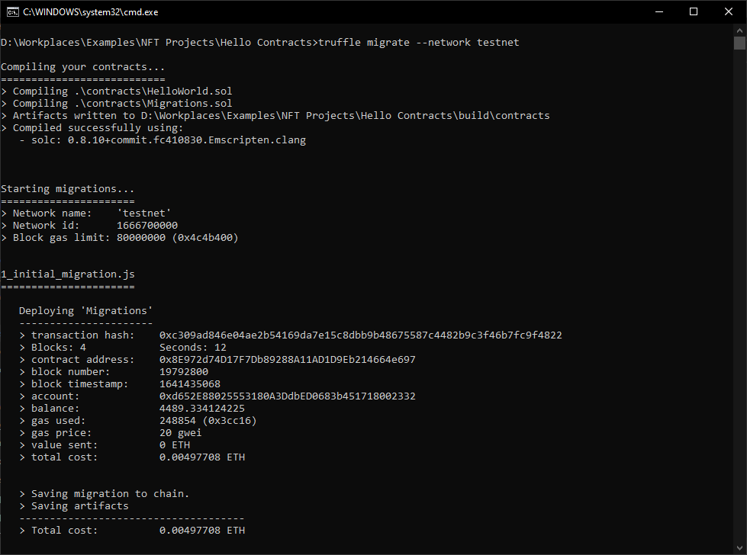

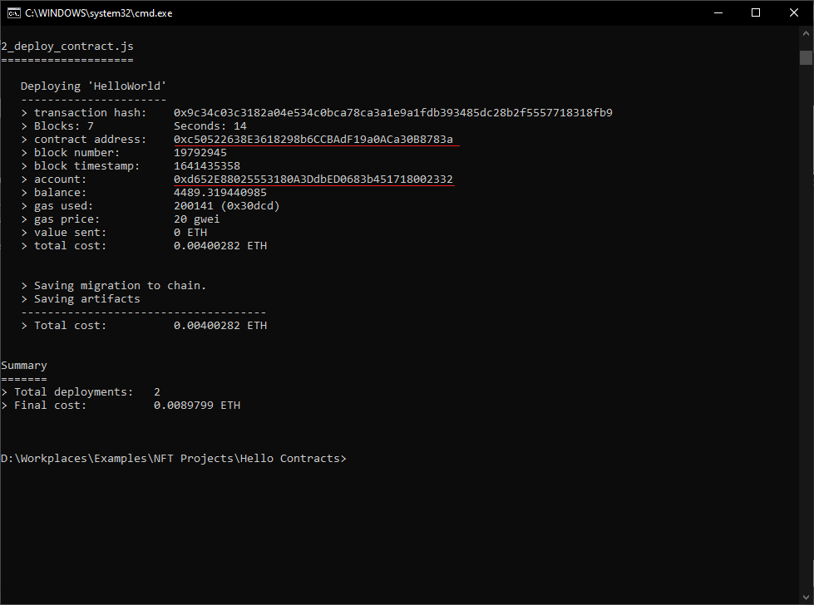

* Check New contracts

Go <https://explorer.testnet.harmony.one/>

And check contract address

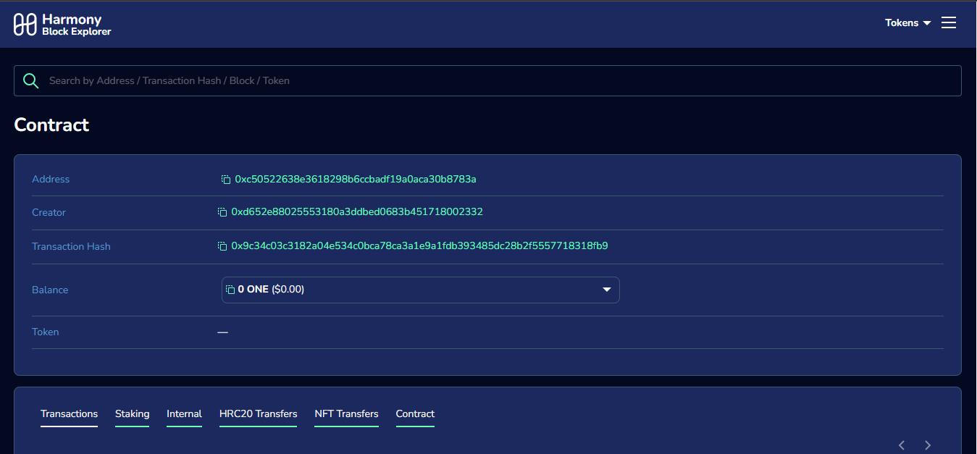

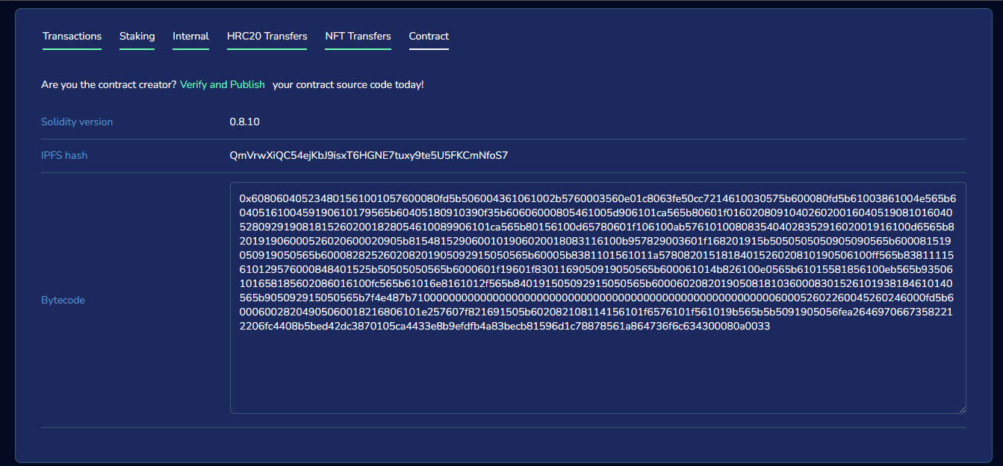

* Support Sites

<https://medium.com/swlh/develop-test-and-deploy-your-first-ethereum-smart-contract-with-truffle-14e8956d69fc>

http://docs.nethereum.com/en/latest/